**Data Aggregation Activity**

*From previous***~(a.**

Create table employee_sales

(Attrition string,

Department string,

JobSatisfaction Int,

Monthlyincome int

);

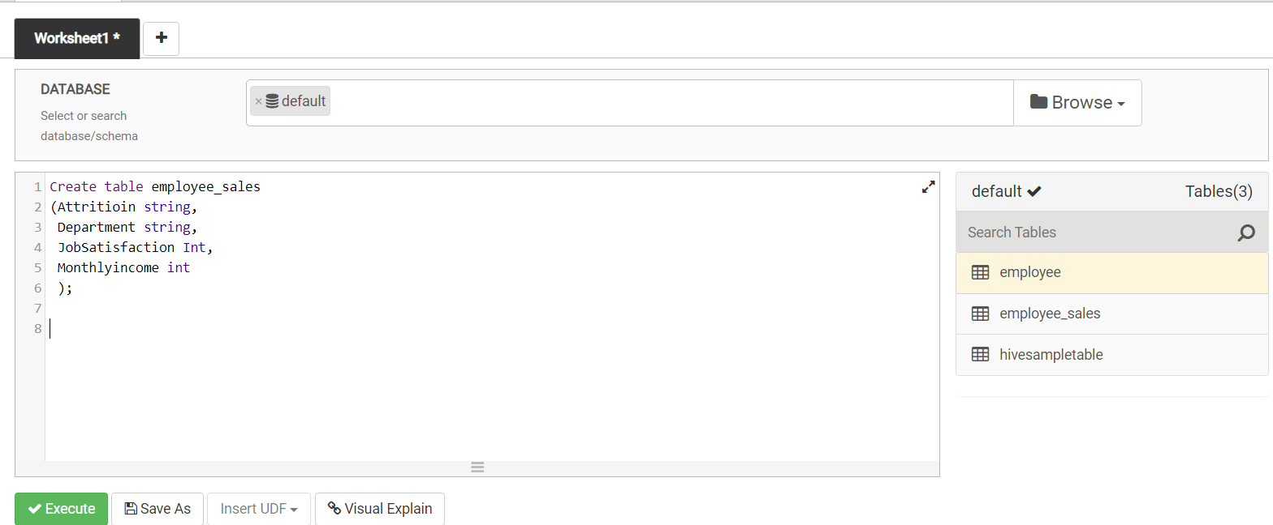

**b.**

*INSERT OVERWRITE TABLE employee_sales*

*Select Attrition, Department, JobSatisfaction, MonthlyIncome*

*From employee;*

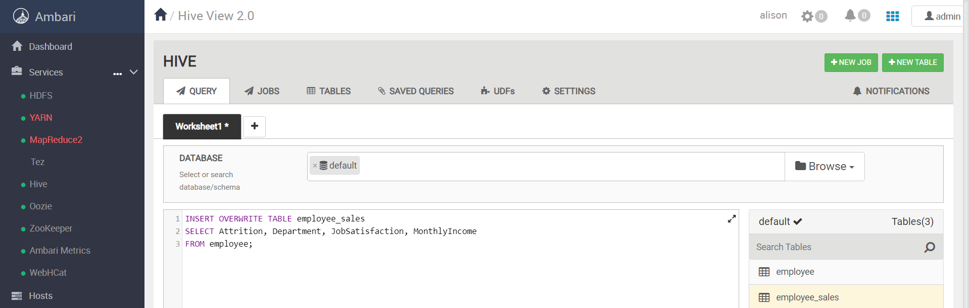

**c.**

*INSERT OVERWRITE TABLE employee_sales*

*SELECT * FROM employee_sales*

*WHERE Department LiKE "%Sales%";*

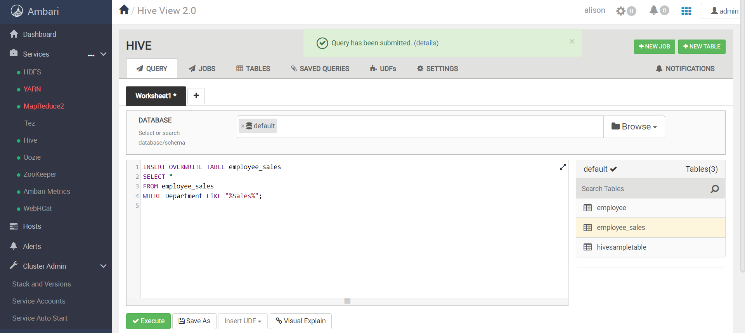

**d.**

SELECT * FROM employee_sales LIMIT 10;

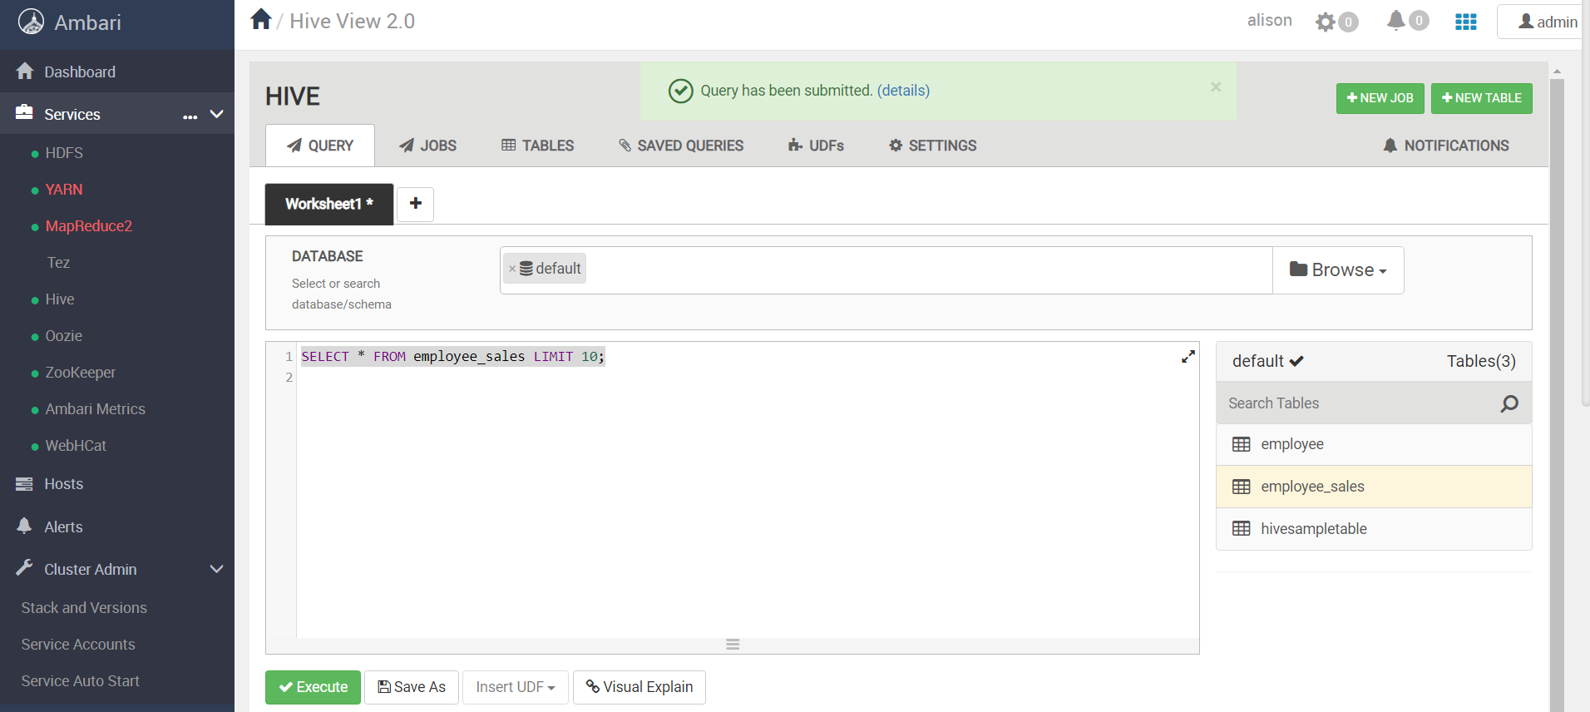

**e.) ~**

1. **Create 2 tables. The first table shows how many salespeople have attrition. Store this information in a column called “attrition”. The second table counts how many salespeople have no attrition. Store this information in a column called “Non Attrition”.**

**Attrition table**

SELECT COUNT(Attrition) AS attrition

FROM employee_sales

WHERE Attrition LIKE "%Yes%";

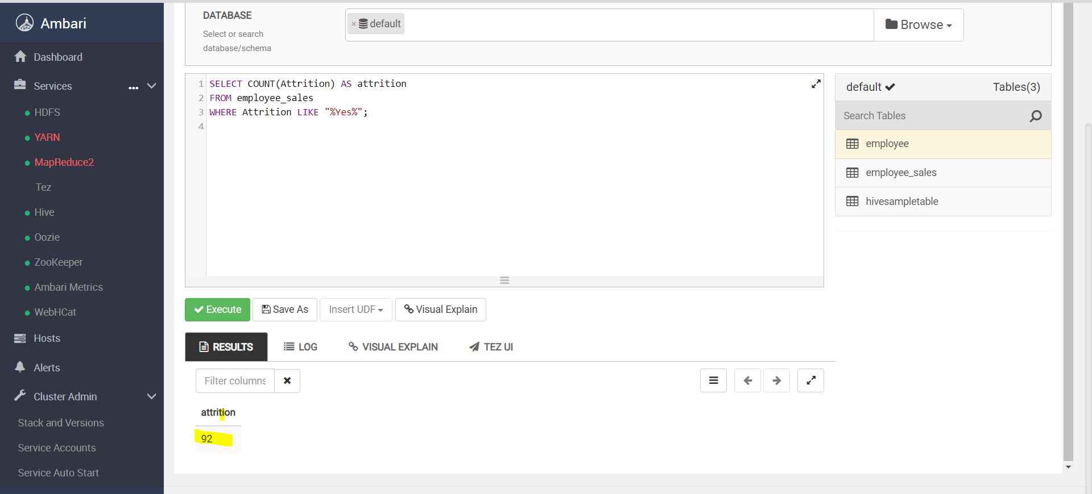

**Non_Attrition table**

SELECT COUNT(Attrition) AS Non_Attrition

FROM employee_sales

WHERE Attrition LIKE "%No%";

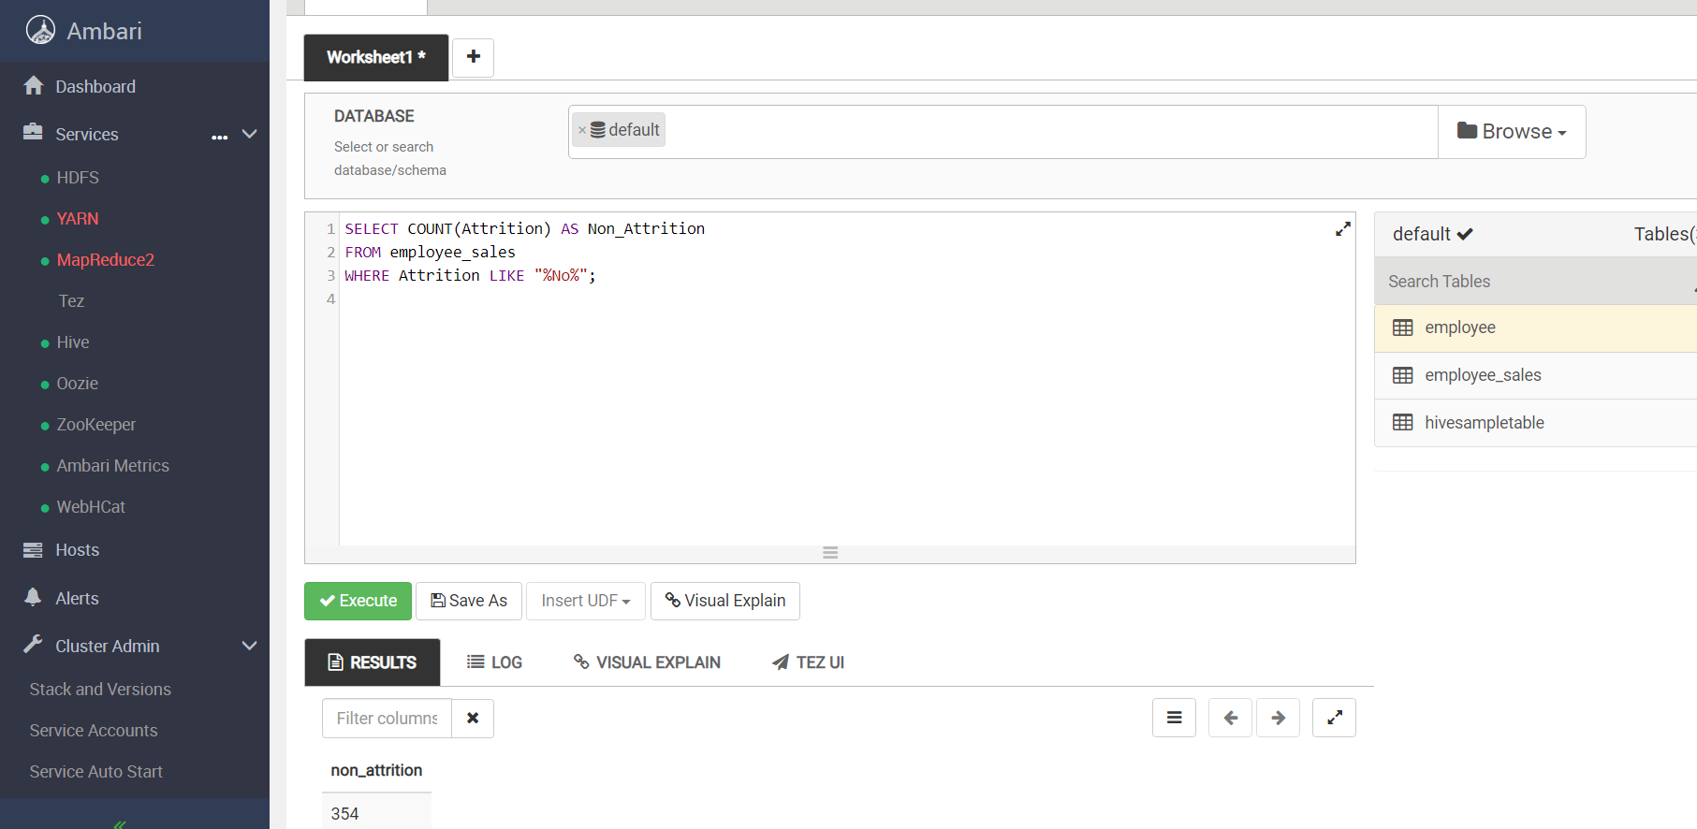

**All_Attrition (92 + 354 = 446)**

*\*Attrition+ Non_Attrition = All_attrition*

SELECT COUNT(Attrition) AS All_Attrition

FROM employee_sales ;

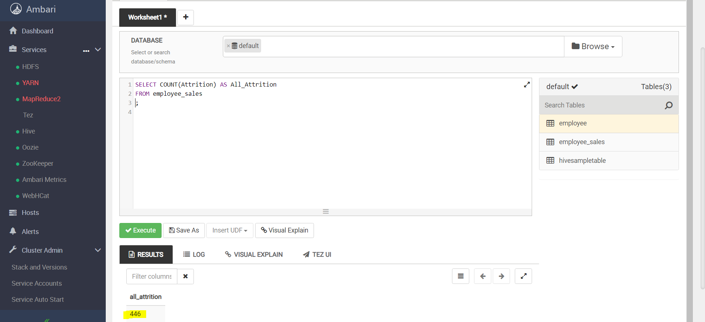

1. **Create 3 statistics tables (average, min, max) showing the monthly income for: all salespeople, those with attrition and those without attrition. For each table, label the columns “average_monthly_income”, “min_monthly_income”, and “max_monthly_income”.**

**a. Attrition table**

*i) average_monthly_income*

SELECT AVG(Monthlyincome) AS average_monthly_income

FROM employee_sales

WHERE Attrition LIKE "%Yes%";

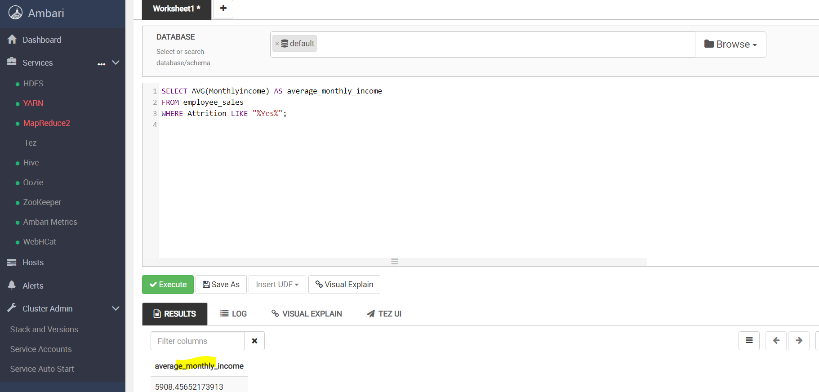

*ii) min_monthly_income*

SELECT Min(Monthlyincome) AS min_monthly_income

FROM employee_sales

WHERE Attrition LIKE "%Yes%";

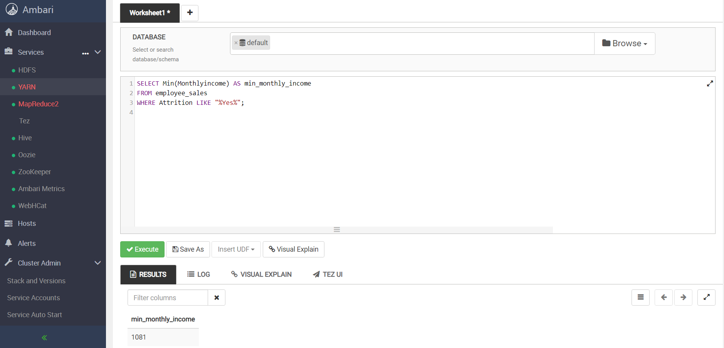

*iii) max_monthly_income*

SELECT Max(Monthlyincome) AS max_monthly_income

FROM employee_sales

WHERE Attrition LIKE "%Yes%";

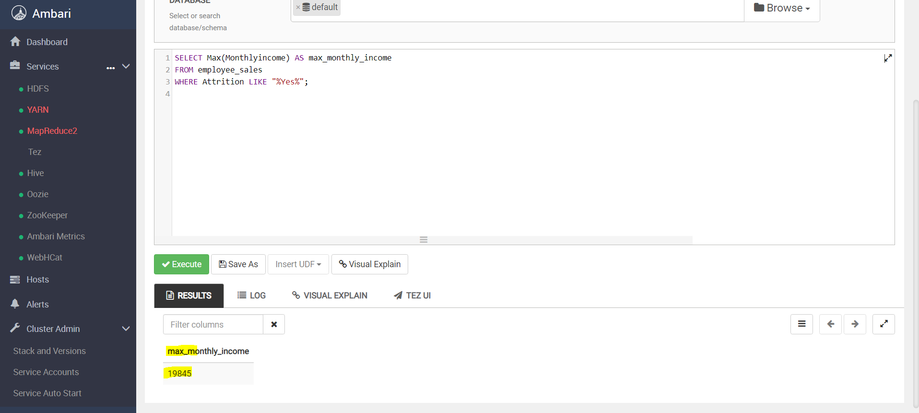

***iv) combined attrition table (avg, min,max)***

SELECT AVG(Monthlyincome) AS average_monthly_income, MIN(Monthlyincome) AS min_monthly_income,

MAX(Monthlyincome) AS max_monthly_income

FROM employee_sales

WHERE Attrition LIKE "%Yes%";

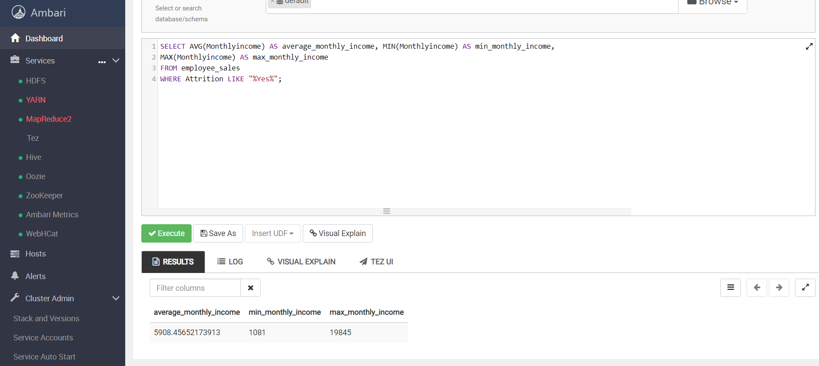

**b. Non_Attrition table**

*i) average_monthly_income*

SELECT AVG(Monthlyincome) AS average_monthly_income

FROM employee_sales

WHERE Attrition LIKE "%No%";

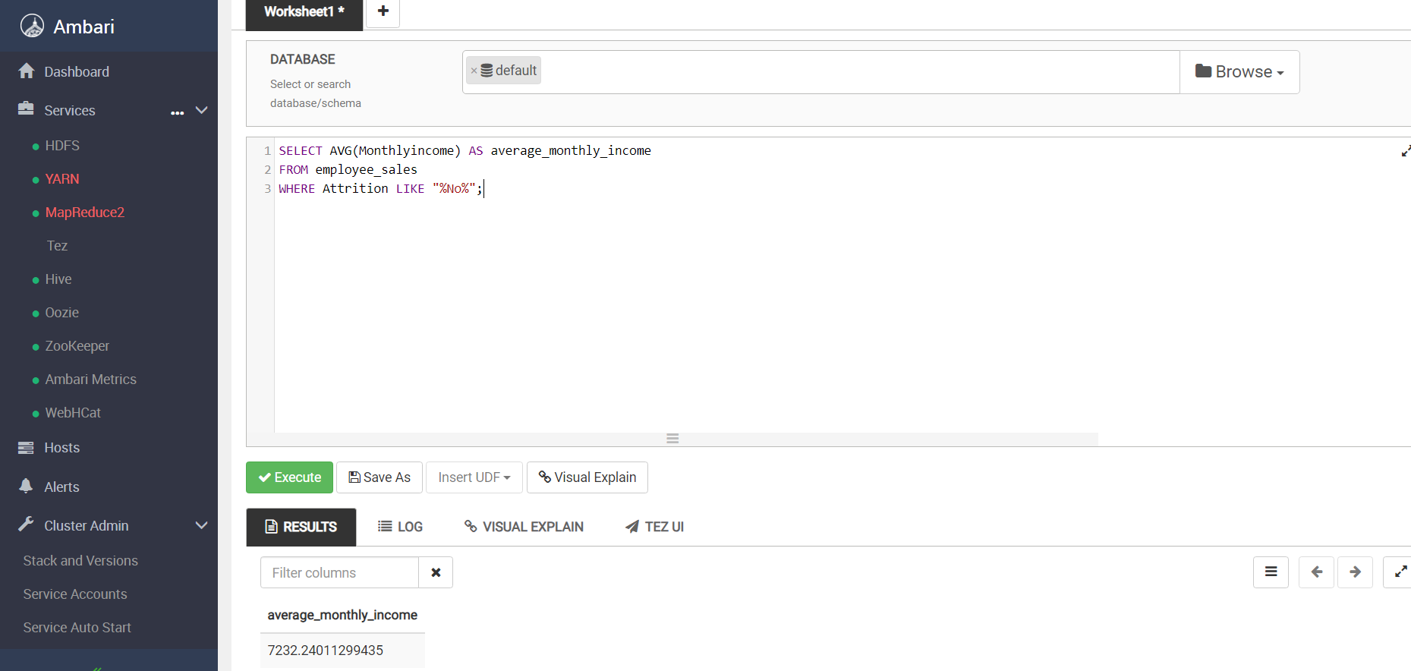

*ii) min_monthly_income*

SELECT Min(Monthlyincome) AS min_monthly_income

FROM employee_sales

WHERE Attrition LIKE "%No%";

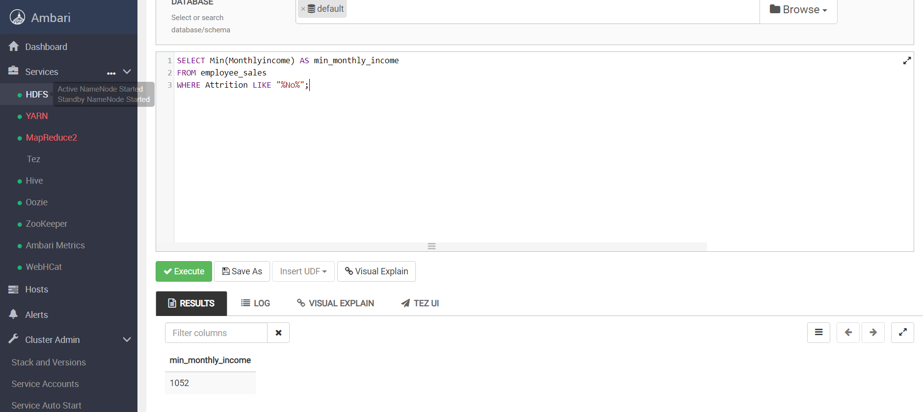

*iii) max_monthly_income*

SELECT Max(Monthlyincome) AS max_monthly_income

FROM employee_sales

WHERE Attrition LIKE "%No%";

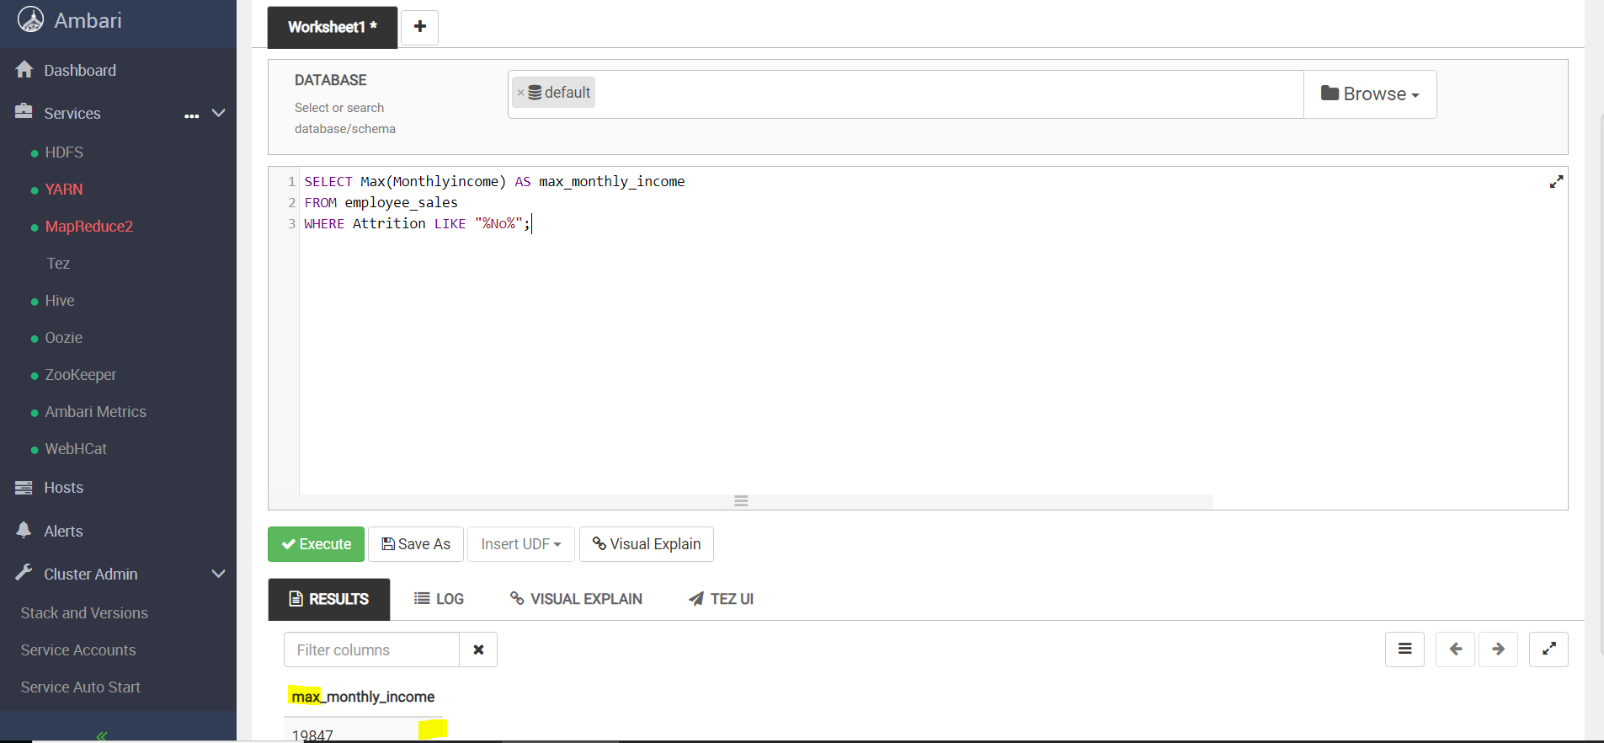

***iv) combined non_attrition table (avg, min,max)***

SELECT AVG(Monthlyincome) AS average_monthly_income, MIN(Monthlyincome) AS min_monthly_income,

MAX(Monthlyincome) AS max_monthly_income

FROM employee_sales

WHERE Attrition LIKE "%No%";

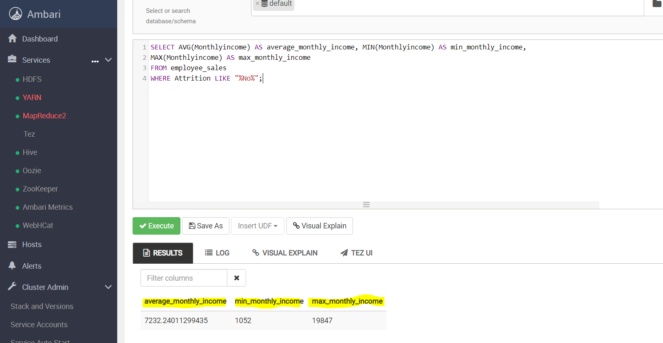

**c. All_Attrition**

SELECT AVG(Monthlyincome) AS average_monthly_income, MIN(Monthlyincome) AS min_monthly_income,

MAX(Monthlyincome) AS max_monthly_income

FROM employee_sales;

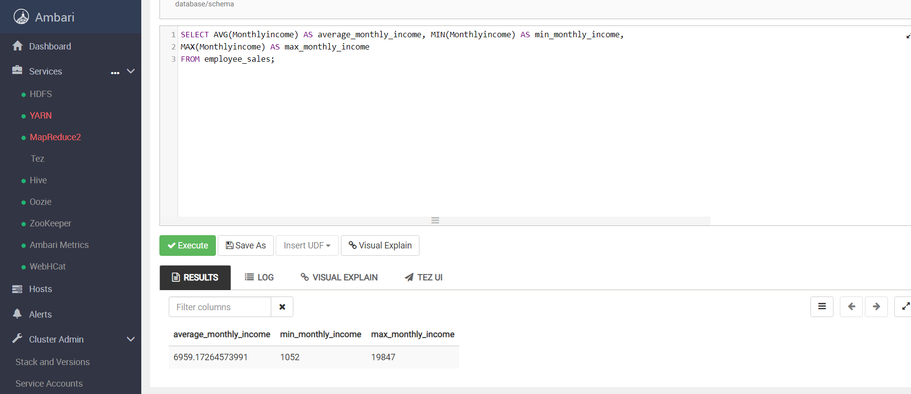

1. **Create 2 tables containing the monthly income and count of salespeople making that monthly income for: salespeople with attrition and salespeople without attrition. Label the columns as: “monthlyincome” and “count”**
2. **Attrition table**

SELECT Monthlyincome AS MonthlyIncome, COUNT(Monthlyincome) AS Count

FROM employee_sales

WHERE Attrition LIKE "%Yes%"

GROUP BY Monthlyincome;

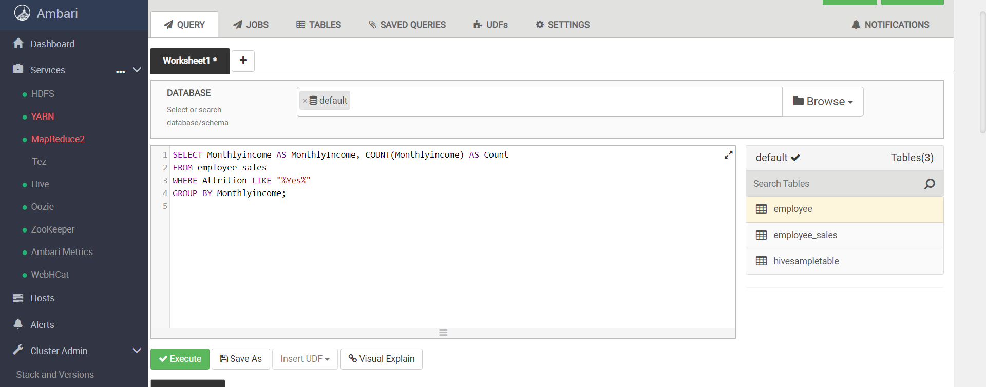

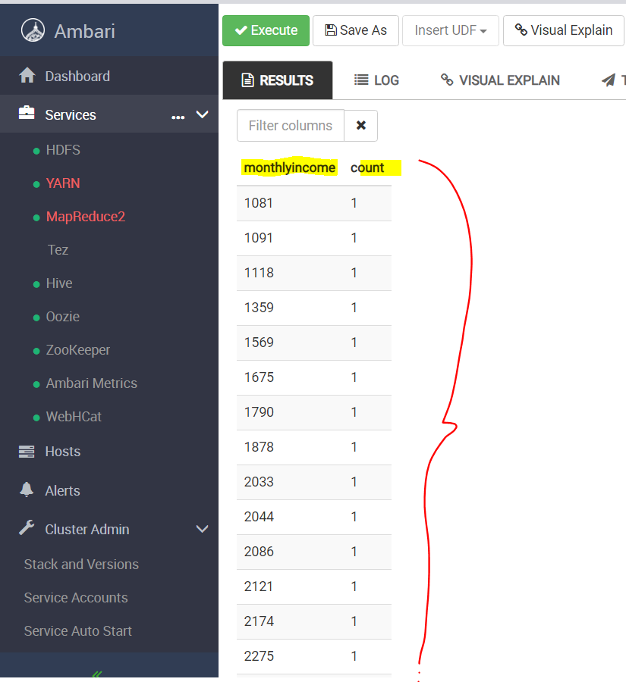

**b. Non_Attrition table**

SELECT Monthlyincome AS MonthlyIncome, COUNT(Monthlyincome) AS Count

FROM employee_sales

WHERE Attrition LIKE "%No%"

GROUP BY Monthlyincome;

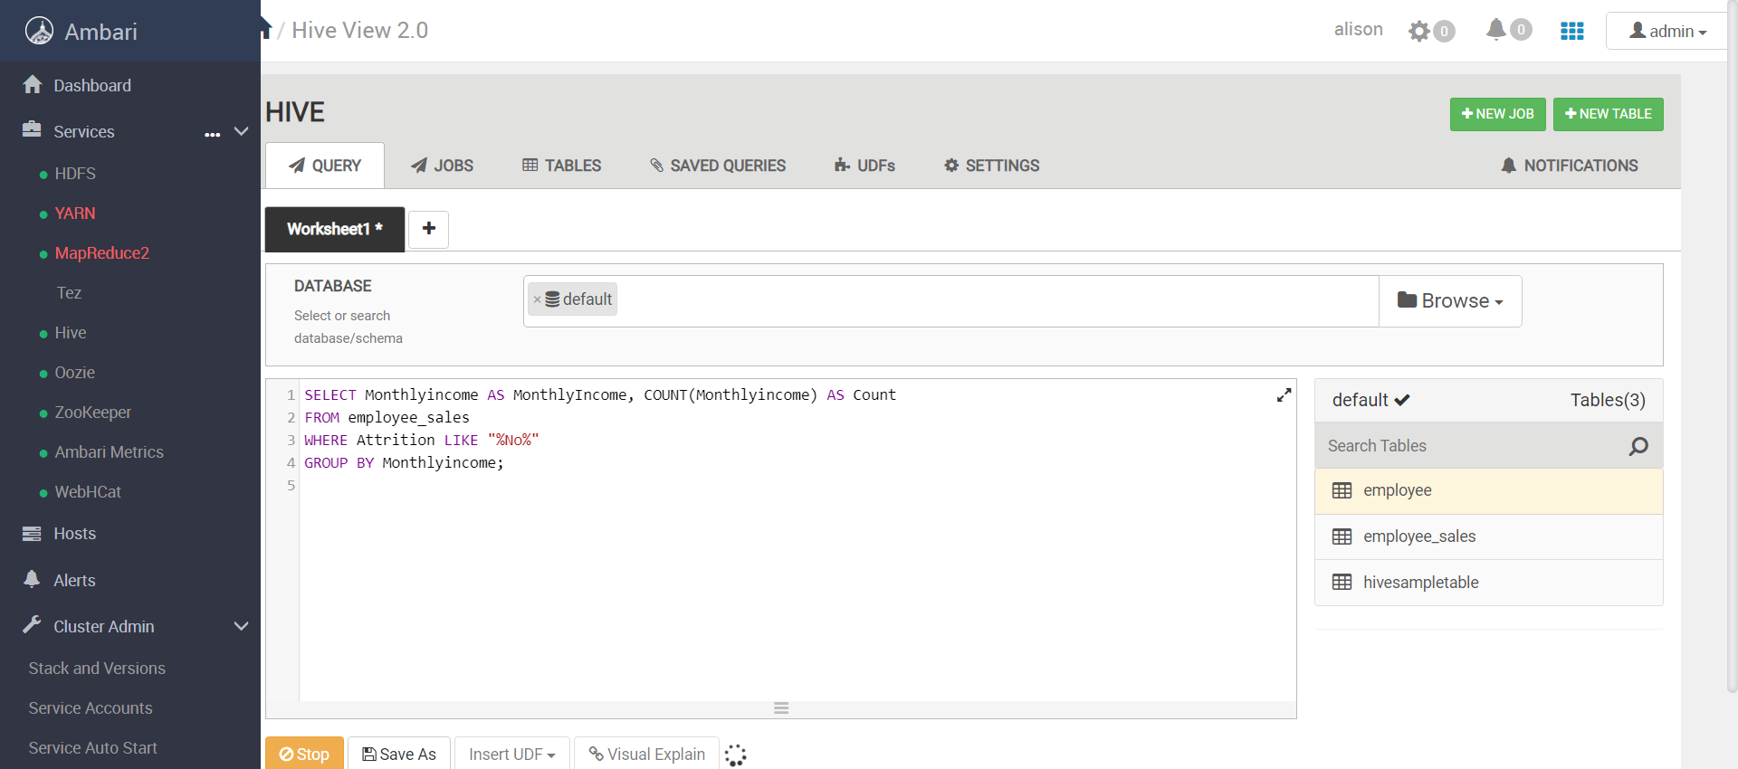

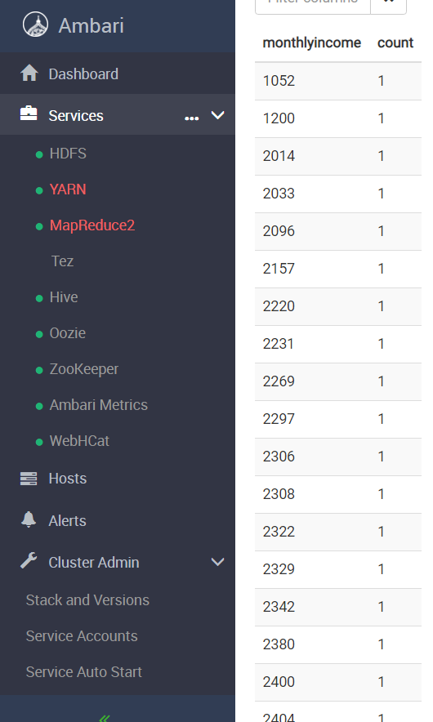

***~~END~~***